**1-DNS In Detail**

**What is DNS?**

DNS (Domain Name System) provides a simple way for us to communicate with devices on the internet without remembering complex numbers. Much like every house has a unique address for sending mail directly to it, every computer on the internet has its own unique address to communicate with it called an IP address. An IP address looks like the following 104.26.10.229, 4 sets of digits ranging from 0 - 255 separated by a period. When you want to visit a website, it's not exactly convenient to remember this complicated set of numbers, and that's where DNS can help. So instead of remembering 104.26.10.229, you can remember tryhackme.com instead.

**Domain Hierarchy**

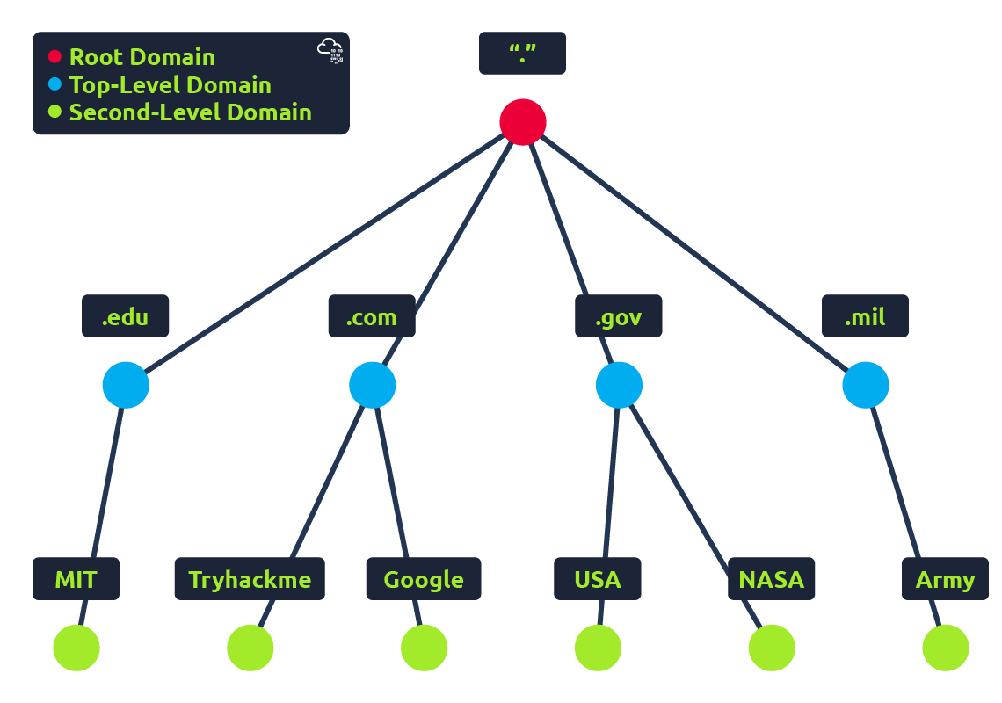

**TLD (Top-Level Domain)**

A TLD is the most righthand part of a domain name. So, for example, the tryhackme.com TLD is **.com**. There are two types of TLD, gTLD (Generic Top Level) and ccTLD (Country Code Top Level Domain). Historically a gTLD was meant to tell the user the domain name's purpose; for example, a .com would be for commercial purposes, .org for an organisation, .edu for education and .gov for government. And a ccTLD was used for geographical purposes, for example, .ca for sites based in Canada, .co.uk for sites based in the United Kingdom and so on. Due to such demand, there is an influx of new gTLDs ranging from .online , .club , .website , .biz and so many more. For a full list of over 2000 TLDs [click here](https://data.iana.org/TLD/tlds-alpha-by-domain.txt).

**Second-Level Domain**

Taking tryhackme.com as an example, the .com part is the TLD, and tryhackme is the Second Level Domain. When registering a domain name, the second-level domain is limited to 63 characters + the TLD and can only use a-z 0-9 and hyphens (cannot start or end with hyphens or have consecutive hyphens).

**Subdomain**

A subdomain sits on the left-hand side of the Second-Level Domain using a period to separate it; for example, in the name admin.tryhackme.com the admin part is the subdomain. A subdomain name has the same creation restrictions as a Second-Level Domain, being limited to 63 characters and can only use a-z 0-9 and hyphens (cannot start or end with hyphens or have consecutive hyphens). You can use multiple subdomains split with periods to create longer names, such as jupiter.servers.tryhackme.com. But the length must be kept to 253 characters or less. There is no limit to the number of subdomains you can create for your domain name.

**DNS Record Types**

DNS isn't just for websites though, and multiple types of DNS record exist. We'll go over some of the most common ones that you're likely to come across.

**A Record**

These records resolve to IPv4 addresses, for example 104.26.10.229

**AAAA Record**

These records resolve to IPv6 addresses, for example 2606:4700:20::681a:be5

**CNAME Record**

These records resolve to another domain name, for example, TryHackMe's online shop has the subdomain name store.tryhackme.com which returns a CNAME record shops.shopify.com. Another DNS request would then be made to shops.shopify.com to work out the IP address.

**MX Record**

These records resolve to the address of the servers that handle the email for the domain you are querying, for example an MX record response for tryhackme.com would look something like alt1.aspmx.l.google.com. These records also come with a priority flag. This tells the client in which order to try the servers, this is perfect for if the main server goes down and email needs to be sent to a backup server.

**TXT Record**

TXT records are free text fields where any text-based data can be stored. TXT records have multiple uses, but some common ones can be to list servers that have the authority to send an email on behalf of the domain (this can help in the battle against spam and spoofed email). They can also be used to verify ownership of the domain name when signing up for third party services.

**Making Request**

**What happens when you make a DNS request**

1. When you request a domain name, your computer first checks its local cache to see if you've previously looked up the address recently; if not, a request to your Recursive DNS Server will be made.
2. A Recursive DNS Server is usually provided by your ISP, but you can also choose your own. This server also has a local cache of recently looked up domain names. If a result is found locally, this is sent back to your computer, and your request ends here (this is common for popular and heavily requested services such as Google, Facebook, Twitter). If the request cannot be found locally, a journey begins to find the correct answer, starting with the internet's root DNS servers.
3. The root servers act as the DNS backbone of the internet; their job is to redirect you to the correct Top Level Domain Server, depending on your request. If, for example, you request [www.tryhackme.com](http://www.tryhackme.com/), the root server will recognise the Top Level Domain of .com and refer you to the correct TLD server that deals with .com addresses.
4. The TLD server holds records for where to find the authoritative server to answer the DNS request. The authoritative server is often also known as the nameserver for the domain. For example, the name server for [tryhackme.com](http://tryhackme.com/) is [kip.ns.cloudflare.com](http://kip.ns.cloudflare.com/) and [uma.ns.cloudflare.com](http://uma.ns.cloudflare.com/). You'll often find multiple nameservers for a domain name to act as a backup in case one goes down.
5. An authoritative DNS server is the server that is responsible for storing the DNS records for a particular domain name and where any updates to your domain name DNS records would be made. Depending on the record type, the DNS record is then sent back to the Recursive DNS Server, where a local copy will be cached for future requests and then relayed back to the original client that made the request. DNS records all come with a TTL (Time To Live) value. This value is a number represented in seconds that the response should be saved for locally until you have to look it up again. Caching saves on having to make a DNS request every time you communicate with a server.

**2-HTTP in Detail**

**What is HTTP? (HyperText Transfer Protocol)**

HTTP is what's used whenever you view a website, developed by Tim Berners-Lee and his team between 1989-1991. HTTP is the set of rules used for communicating with web servers for the transmitting of webpage data, whether that is HTML, Images, Videos, etc.

**What is HTTPS? (HyperText Transfer Protocol Secure)**

HTTPS is the secure version of HTTP. HTTPS data is encrypted so it not only stops people from seeing the data you are receiving and sending, but it also gives you assurances that you're talking to the correct web server and not something impersonating it.

Request and Responses

When we access a website, your browser will need to make requests to a web server for assets such as HTML, Images, and download the responses. Before that, you need to tell the browser specifically how and where to access these resources, this is where URLs will help.

**What is a URL? (Uniform Resource Locator)**

If you’ve used the internet, you’ve used a URL before. A URL is predominantly an instruction on how to access a resource on the internet. The below image shows what a URL looks like with all of its features (it does not use all features in every request).

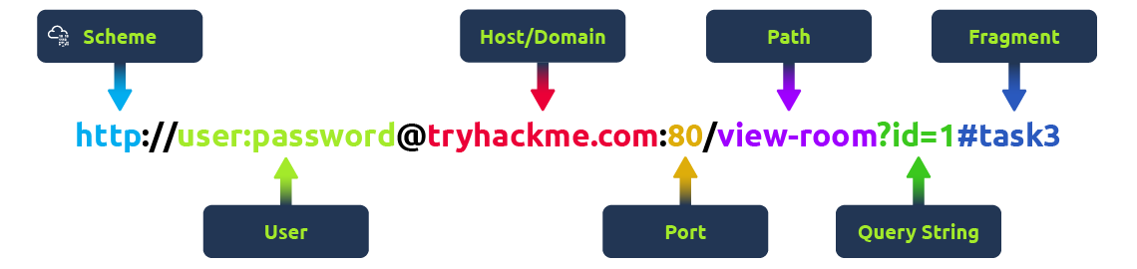

**Scheme:** This instructs on what protocol to use for accessing the resource such as HTTP, HTTPS, FTP (File Transfer Protocol).

**User:** Some services require authentication to log in, you can put a username and password into the URL to log in.

**Host:** The domain name or IP address of the server you wish to access.

**Port:** The Port that you are going to connect to, usually 80 for HTTP and 443 for HTTPS, but this can be hosted on any port between 1 - 65535.

**Path:** The file name or location of the resource you are trying to access.

**Query String:** Extra bits of information that can be sent to the requested path. For example, /blog?**id=1**would tell the blog path that you wish to receive the blog article with the id of 1.

**Fragment:**This is a reference to a location on the actual page requested. This is commonly used for pages with long content and can have a certain part of the page directly linked to it, so it is viewable to the user as soon as they access the page.

**Making a Request**

It's possible to make a request to a web server with just one line "**GET / HTTP/1.1**"

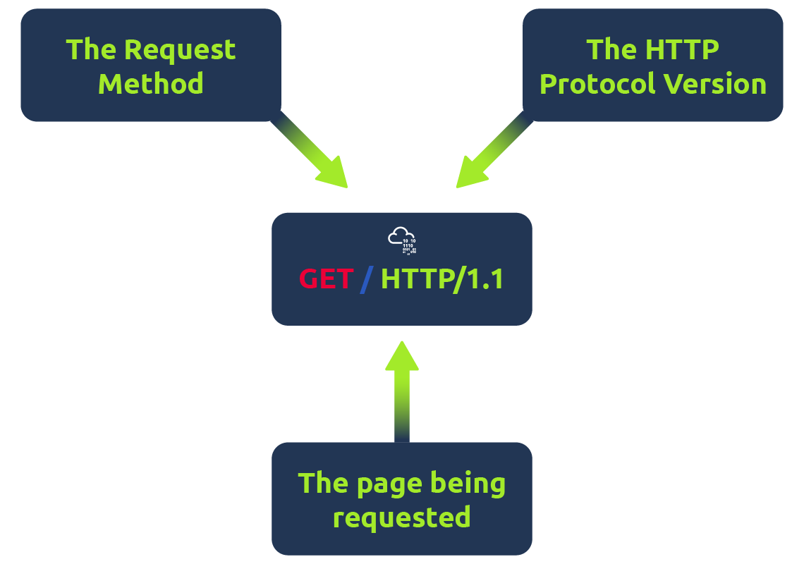

But for a much richer web experience, you’ll need to send other data as well. This other data is sent in what is called headers, where headers contain extra information to give to the web server you’re communicating with, but we’ll go more into this in the Header task.

**Example Request:**

GET / HTTP/1.1

Host: tryhackme.com

User-Agent: Mozilla/5.0 Firefox/87.0

Referer: https://tryhackme.com/

To breakdown each line of this request:

**Line 1:** This request is sending the GET method ( more on this in the HTTP Methods task ), request the home page with / and telling the web server we are using HTTP protocol version 1.1.

**Line 2:** We tell the web server we want the website tryhackme.com

**Line 3:** We tell the web server we are using the Firefox version 87 Browser

**Line 4:** We are telling the web server that the web page that referred us to this one is [https://tryhackme.com](https://tryhackme.com/)

**Line 5:**HTTP requests always end with a blank line to inform the web server that the request has finished.

**Example Response:**

HTTP/1.1 200 OK

Server: nginx/1.15.8

Date: Fri, 09 Apr 2021 13:34:03 GMT

Content-Type: text/html

Content-Length: 98

<html>

<head>

<title>TryHackMe</title>

</head>

<body>

Welcome To TryHackMe.com

</body>

</html>

To breakdown each line of the response:

**Line 1:**HTTP 1.1 is the version of the HTTP protocol the server is using and then followed by the HTTP Status Code in this case "200 Ok" which tells us the request has completed successfully.

**Line 2:** This tells us the web server software and version number.

**Line 3:** The current date, time and timezone of the web server.

**Line 4:** The Content-Type header tells the client what sort of information is going to be sent, such as HTML, images, videos, pdf, XML.

**Line 5:** Content-Length tells the client how long the response is, this way we can confirm no data is missing.

**Line 6:** HTTP response contains a blank line to confirm the end of the HTTP response.

**Lines 7-14:** The information that has been requested, in this instance the homepage.

HTTP Methods

HTTP methods are a way for the client to show their intended action when making an HTTP request. There are a lot of HTTP methods but we'll cover the most common ones, although mostly you'll deal with the GET and POST method.

**GET Request**

This is used for getting information from a web server.

**POST Request**

This is used for submitting data to the web server and potentially creating new records

**PUT Request**

This is used for submitting data to a web server to update information

**DELETE Request**

This is used for deleting information/records from a web server.

HTTP Status Code

**HTTP Status Codes:**

In the previous task, you learnt that when a HTTP server responds, the first line always contains a status code informing the client of the outcome of their request and also potentially how to handle it. These status codes can be broken down into 5 different ranges:

|  |  |
| --- | --- |
| **100-199 - Information Response** | These are sent to tell the client the first part of their request has been accepted and they should continue sending the rest of their request. These codes are no longer very common. |
| **200-299 - Success** | This range of status codes is used to tell the client their request was successful. |
| **300-399 - Redirection** | These are used to redirect the client's request to another resource. This can be either to a different webpage or a different website altogether. |
| **400-499 - Client Errors** | Used to inform the client that there was an error with their request. |
| **500-599 - Server Errors** | This is reserved for errors happening on the server-side and usually indicate quite a major problem with the server handling the request. |

**Common HTTP Status Codes:**

There are a lot of different HTTP status codes and that's not including the fact that applications can even define their own, we'll go over the most common HTTP responses you are likely to come across:

|  |  |
| --- | --- |
| **200 - OK** | The request was completed successfully. |
| **201 - Created** | A resource has been created (for example a new user or new blog post). |
| **301 - Moved Permanently** | This redirects the client's browser to a new webpage or tells search engines that the page has moved somewhere else and to look there instead. |
| **302 - Found** | Similar to the above permanent redirect, but as the name suggests, this is only a temporary change and it may change again in the near future. |
| **400 - Bad Request** | This tells the browser that something was either wrong or missing in their request. This could sometimes be used if the web server resource that is being requested expected a certain parameter that the client didn't send. |
| **401 - Not Authorised** | You are not currently allowed to view this resource until you have authorised with the web application, most commonly with a username and password. |
| **403 - Forbidden** | You do not have permission to view this resource whether you are logged in or not. |
| **405 - Method Not Allowed** | The resource does not allow this method request, for example, you send a GET request to the resource /create-account when it was expecting a POST request instead. |
| **404 - Page Not Found** | The page/resource you requested does not exist. |
| **500 - Internal Service Error** | The server has encountered some kind of error with your request that it doesn't know how to handle properly. |
| **503 - Service Unavailable** | This server cannot handle your request as it's either overloaded or down for maintenance. |

Click the "View Site" button on the right to see what some of these HTTP status messages look like in a browser.

Header

Headers are additional bits of data you can send to the web server when making requests.

Although no headers are strictly required when making a HTTP request, you’ll find it difficult to view a website properly.

**Common Request Headers**

﻿These are headers that are sent from the client (usually your browser) to the server.

**Host:** Some web servers host multiple websites so by providing the host headers you can tell it which one you require, otherwise you'll just receive the default website for the server.

**User-Agent:** This is your browser software and version number, telling the web server your browser software helps it format the website properly for your browser and also some elements of HTML, JavaScript and CSS are only available in certain browsers.

**Content-Length:** When sending data to a web server such as in a form, the content length tells the web server how much data to expect in the web request. This way the server can ensure it isn't missing any data.

**Accept-Encoding:** Tells the web server what types of compression methods the browser supports so the data can be made smaller for transmitting over the internet.

**Cookie:** Data sent to the server to help remember your information (see cookies task for more information).

**Common Response Headers**

These are the headers that are returned to the client from the server after a request.

**Set-Cookie:** Information to store which gets sent back to the web server on each request (see cookies task for more information).

**Cache-Control:** How long to store the content of the response in the browser's cache before it requests it again.

**Content-Type:** This tells the client what type of data is being returned, i.e., HTML, CSS, JavaScript, Images, PDF, Video, etc. Using the content-type header the browser then knows how to process the data.

**Content-Encoding:**What method has been used to compress the data to make it smaller when sending it over the internet.

Cookies

ou've probably heard of cookies before, they're just a small piece of data that is stored on your computer. Cookies are saved when you receive a "Set-Cookie" header from a web server. Then every further request you make, you'll send the cookie data back to the web server. Because HTTP is stateless (doesn't keep track of your previous requests), cookies can be used to remind the web server who you are, some personal settings for the website or whether you've been to the website before. Let's take a look at this as an example HTTP request:

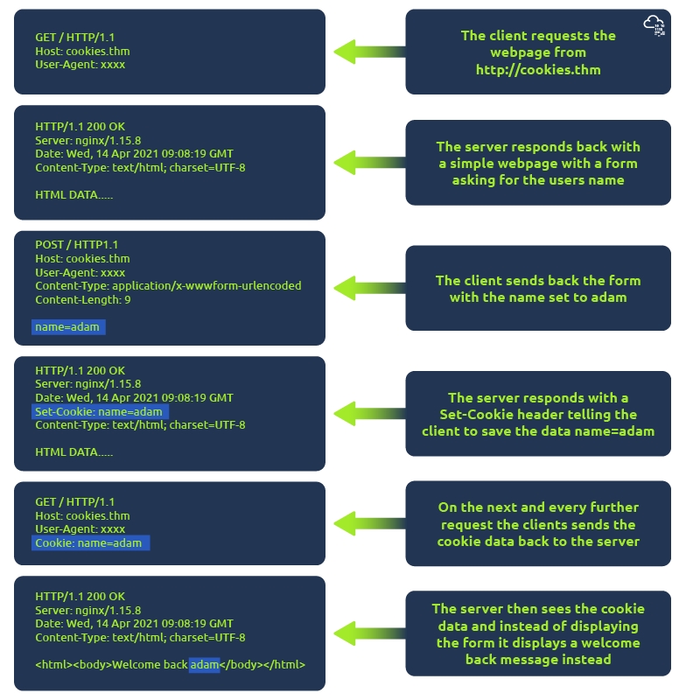

Cookies can be used for many purposes but are most commonly used for website authentication. The cookie value won't usually be a clear-text string where you can see the password, but a token (unique secret code that isn't easily humanly guessable).

**Viewing Your Cookies**

**You can easily view what cookies your browser is sending to a website by using the developer tools, in your browser. If you're not sure how to get to the developer tools in your browser, click on the "View Site" button at the top of this task for a how-to guide.**

**Once you have developer tools open, click on the "Network" tab. This tab will show you a list of all the resources your browser has requested. You can click on each one to receive a detailed breakdown of the request and response. If your browser sent a cookie, you will see these on the "Cookies" tab of the request.**

**3- How to Web Works**

**How to web works**

By the end of this room, you'll know how websites are created and will be introduced to some basic security issues.

When you visit a website, your browser (*like Safari or Google Chrome*) makes a request to a web server asking for information about the page you're visiting. It will respond with data that your browser uses to show you the page; a web server is just a dedicated computer somewhere else in the world that handles your requests.

There are two major components that make up a website:

1. Front End (Client-Side) - the way your browser renders a website.
2. Back End (Server-Side) - a server that processes your request and returns a response.

There are many other processes involved in your browser making a request to a web server, but for now, you just need to understand that you make a request to a server, and it responds with data your browser uses to render information to you.

HTML

Websites are primarily created using:

* HTML, to build websites and define their structure
* CSS, to make websites look pretty by adding styling options
* JavaScript, implement complex features on pages using interactivity

**H**yper**T**ext **M**arkup **L**anguage (HTML) is the language websites are written in. Elements (also known as tags) are the building blocks of HTML pages and tells the browser how to display content. The code snippet below shows a simple HTML document, the structure of which is the same for every website:

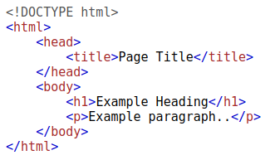

The HTML structure (as shown in the screenshot) has the following components:

* The <!DOCTYPE html> defines that the page is a HTML5 document. This helps with standardisation across different browsers and tells the browser to use HTML5 to interpret the page.
* The <html> element is the root element of the HTML page - all other elements come after this element.
* The <head> element contains information about the page (such as the page title)
* The <body> element defines the HTML document's body; only content inside of the body is shown in the browser.
* The <h1> element defines a large heading
* The <p> element defines a paragraph
* There are many other elements (tags) used for different purposes. For example, there are tags for buttons (<button>), images (<img>), lists, and much more.

Tags can contain attributes such as the class attribute which can be used to style an element (e.g. make the tag a different color) <p class="bold-text">, or the *src*attribute which is used on images to specify the location of an image: <img src="img/cat.jpg">.An element can have multiple attributes each with its own unique purpose, e.g., <p attribute1="value1" attribute2="value2">.

Elements can also have an id attribute (<p id="example">), which is unique to the element. Unlike the class attribute, where multiple elements can use the same class, an element must have different id's to identify them uniquely. Element id's are used for styling and to identify it by JavaScript.

You can view the HTML of any website by right-clicking and selecting "View Page Source" (Chrome) / "Show Page Source" (Safari).

JavaScript

JavaScript (JS) is one of the most popular coding languages in the world and allows pages to become interactive. HTML is used to create the website structure and content, while JavaScript is used to control the functionality of web pages - without JavaScript, a page would not have interactive elements and would always be static. JS can dynamically update the page in real-time, giving functionality to change the style of a button when a particular event on the page occurs (such as when a user clicks a button) or to display moving animations.

JavaScript is added within the page source code and can be either loaded within <script> tags or can be included remotely with the src attribute: <script src="/location/of/javascript_file.js"></script>

The following JavaScript code finds a HTML element on the page with the id of "demo" and changes the element's contents to "Hack the Planet" : document.getElementById("demo").innerHTML = "Hack the Planet";

HTML elements can also have events, such as "onclick" or "onhover" that execute JavaScript when the event occurs. The following code changes the text of the element with the demo ID to Button Clicked: <button onclick='document.getElementById("demo").innerHTML = "Button Clicked";'>Click Me!</button> - onclick events can also be defined inside the JavaScript script tags, and not on elements directly.

Sensitive Data Exposure

Sensitive Data Exposure occurs when a website doesn't properly protect (or remove) sensitive clear-text information to the end-user; usually found in a site's frontend source code.

We now know that websites are built using many HTML elements (tags), all of which we can see simply by "viewing the page source". A website developer may have forgotten to remove login credentials, hidden links to private parts of the website or other sensitive data shown in HTML or JavaScript.

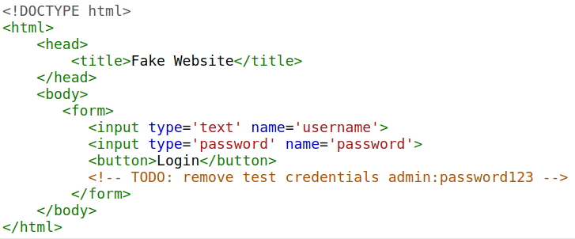Sensitive information can be potentially leveraged to further an attacker's access within different parts of a web application. For example, there could be HTML comments with temporary login credentials, and if you viewed the page's source code and found this, you could use these credentials to log in elsewhere on the application (or worse, used to access other backend components of the site).

Whenever you're assessing a web application for security issues, one of the first things you should do is review the page source code to see if you can find any exposed login credentials or hidden links.

HTML Injection

HTML Injection is a vulnerability that occurs when unfiltered user input is displayed on the page. If a website fails to sanitise user input (filter any "malicious" text that a user inputs into a website), and that input is used on the page, an attacker can inject HTML code into a vulnerable website.

Input sanitisation is very important in keeping a website secure, as information a user inputs into a website is often used in other frontend and backend functionality. A vulnerability you'll explore in another lab is database injection, where you can manipulate a database lookup query to log in as another user by controlling the input that's directly used in the query - but for now, let's focus on HTML injection (which is client-side).

When a user has control of how their input is displayed, they can submit HTML (or JavaScript) code, and the browser will use it on the page, allowing the user to control the page's appearance and functionality.

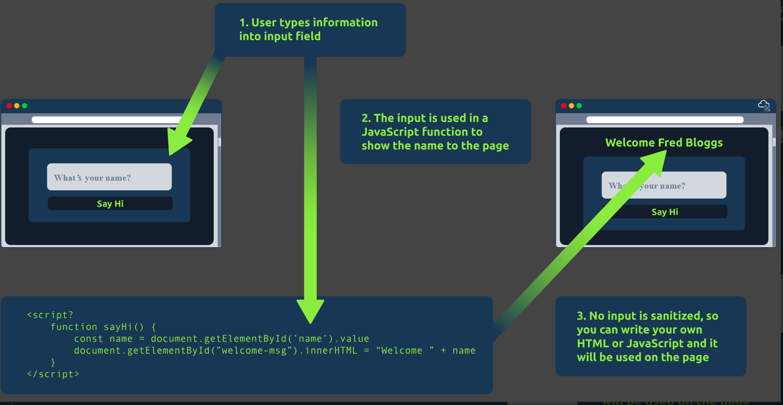

The image above shows how a form outputs text to the page. Whatever the user inputs into the "What's your name" field is passed to a JavaScript function and output to the page, which means if the user adds their own HTML or JavaScript in the field, it's used in the sayHi function and is added to the page - this means you can add your own HTML (such as a <h1> tag) and it will output your input as pure HTML.

The general rule is never to trust user input. To prevent malicious input, the website developer should sanitise everything the user enters before using it in the JavaScript function; in this case, the developer could remove any HTML tags.

**4-Putting it altogether**

Putting It All Together

From the previous modules, you'll have learned that quite a lot of things go on behind the scenes when you request a webpage in your browser.

To summarise, when you request a website, your computer needs to know the server's IP address it needs to talk to; for this, it uses DNS. Your computer then talks to the web server using a special set of commands called the HTTP protocol; the webserver then returns HTML, JavaScript, CSS, Images, etc., which your browser then uses to correctly format and display the website to you.

There are also a few other components that help the web run more efficiently and provide extra features.

Other Components

**Load Balancers**

When a website's traffic starts getting quite large or is running an application that needs to have high availability, one web server might no longer do the job. Load balancers provide two main features, ensuring high traffic websites can handle the load and providing a failover if a server becomes unresponsive.

When you request a website with a load balancer, the load balancer will receive your request first and then forward it to one of the multiple servers behind it. The load balancer uses different algorithms to help it decide which server is best to deal with the request. A couple of examples of these algorithms are **round-robin**, which sends it to each server in turn, or **weighted**, which checks how many requests a server is currently dealing with and sends it to the least busy server.

Load balancers also perform periodic checks with each server to ensure they are running correctly; this is called a **health check**. If a server doesn't respond appropriately or doesn't respond, the load balancer will stop sending traffic until it responds appropriately again.

**CDN (Content Delivery Networks)**

A CDN can be an excellent resource for cutting down traffic to a busy website. It allows you to host static files from your website, such a JavaScript, CSS, Images, Videos, and host them across thousands of servers all over the world. When a user requests one of the hosted files, the CDN works out where the nearest server is physically located and sends the request there instead of potentially the other side of the world.

**Databases**

Often websites will need a way of storing information for their users. Webservers can communicate with databases to store and recall data from them. Databases can range from just a simple plain text file up to complex clusters of multiple servers providing speed and resilience. You'll come across some common databases: MySQL, MSSQL, MongoDB, GraphQL, Postgres, and more; each has its specific features.

**WAF (Web Application Firewall)**

A WAF sits between your web request and the web server; its primary purpose is to protect the webserver from hacking or denial of service attacks. It analyses the web requests for common attack techniques, whether the request is from a real browser rather than a bot. It also checks if an excessive amount of web requests are being sent by utilising something called rate limiting, which will only allow a certain amount of requests from an IP per second. If a request is deemed a potential attack, it will be dropped and never sent to the webserver.

How Web servers work**.**

**What is a Web Server?**

A web server is a software that listens for incoming connections and then utilises the HTTP protocol to deliver web content to its clients. The most common web server software you'll come across is Apache, Nginx, IIS and NodeJS. A Web server delivers files from what's called its root directory, which is defined in the software settings. For example, Nginx and Apache share the same default location of /var/www/html in Linux operating systems, and IIS uses C:\inetpub\wwwroot for the Windows operating systems. So, for example, if you requested the file <http://www.example.com/picture.jpg>, it would send the file /var/www/html/picture.jpg from its local hard drive.

**Virtual Hosts**

Web servers can host multiple websites with different domain names; to achieve this, they use virtual hosts. The web server software checks the hostname being requested from the HTTP headers and matches that against its virtual hosts (virtual hosts are just text-based configuration files). If it finds a match, the correct website will be provided. If no match is found, the default website will be provided instead.

Virtual Hosts can have their root directory mapped to different locations on the hard drive. For example, [one.com](http://one.com/) being mapped to /var/www/website_one, and [two.com](http://two.com/) being mapped to /var/www/website_two

There's no limit to the number of different websites you can host on a web server.

**Static Vs Dynamic Content**

Static content, as the name suggests, is content that never changes. Common examples of this are pictures, javascript, CSS, etc., but can also include HTML that never changes. Furthermore, these are files that are directly served from the webserver with no changes made to them.

Dynamic content, on the other hand, is content that could change with different requests. Take, for example, a blog. On the homepage of the blog, it will show you the latest entries. If a new entry is created, the home page is then updated with the latest entry, or a second example might be a search page on a blog. Depending on what word you search, different results will be displayed.

These changes to what you end up seeing are done in what is called the **Backend** with the use of programming and scripting languages. It's called the Backend because what is being done is all done behind the scenes. You can't view the websites' HTML source and see what's happening in the Backend, while the HTML is the result of the processing from the Backend. Everything you see in your browser is called the **Frontend.**

**Scripting and Backend Languages**

There's not much of a limit to what a backend language can achieve, and these are what make a website interactive to the user. Some examples of these languages (in no particular order :p) are PHP, Python, Ruby, NodeJS, Perl and many more. These languages can interact with databases, call external services, process data from the user, and so much more. A very basic PHP example of this would be if you requested the website <http://example.com/index.php?name=adam>

If index.php was built like this:

<html><body>Hello **<?php** echo $_GET["name"]; **?>**</body></html>

It would output the following to the client:

<html><body>Hello adam</body></html>

You'll notice that the client doesn't see any PHP code because it's on the **Backend**. This interactivity opens up a lot more security issues for web applications that haven't been created securely, as you learn in further modules.